P. 43 Progetto

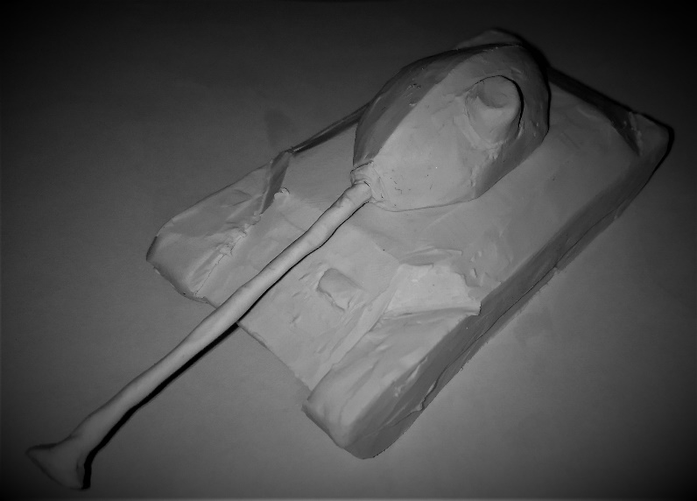

This is a clay model of my design.

135
140
6.5/5.5/4.7
35.0
-9/20
16.75/1.5/3
2.00
0.38
1705

720
60/35/25
70/25/20

28.2/30.5
600
21.27

15.0/5.0
10.0/3.0

380
525

FIREPOWER
Average Damage per Shot
Average Penetration
Time for Autoreloading One Shell
Gun Traverse Speed
Gun Depression/Elevation Angles
Load
Aim Time
Dispersion at 100 m
Average Damage per Minute

SURVIVABILITY
Hit Points
Hull Armor
Turret Armor

MOBILITY
Weight/Load Limit
Engine Power
Specific Power*

CONCEALMENT
Concealment of Stationary Vehicle
Concealment of Moving Vehicle

SPOTTING
View Range *
Radio Range

*these are the parts that may be too powerful

